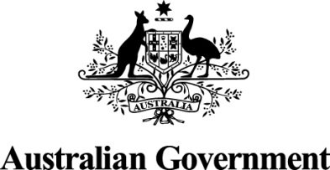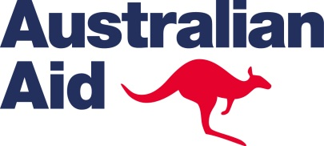

DIRECT AID PROGRAM

What is the Direct Aid Program (DAP)?
The Direct Aid Program (DAP) is a flexible small grants program run directly by the Australian High Commission in Abuja (and by around 50 other Australian overseas missions).

Who can apply?
DAP funding is available to community groups, reputable local, international or Australian NGOs, private sector entities, academic institutions, research bodies, libraries, museums, or other organisations engaged in development activities on a not-for-profit basis.

The High Commission accepts project proposals from all of its countries of accreditation: Benin, Cameroon, Gabon, Gambia, Niger and Nigeria.

Suitable activities for DAP funding:
DAP is primarily aimed at supporting small-scale sustainable development projects and activities that are participatory in nature and, preferably, which actively engage the beneficiaries in the design, development, and implementation of the project.

Eligible sectors include, but are not limited to:

- education;
- agriculture;
- poverty alleviation;
- youth empowerment;
- research;
- promotion of human rights;
- infrastructure;
- governance;
- health;
- water and sanitation; and
- environment/conservation.

Special attention is given to activities that:

- promote gender equality and women’s empowerment; and/or
- include and benefit people with disabilities; and/or
- support local COVID-19 response and recovery efforts.

Consideration can also be given to projects that:
- focus on the preservation of culture or sporting projects with clear development links;
- support humanitarian and disaster relief operations; or
- involve capacity building activities where a compelling case can be made for clear skills transfer or other tangible benefits for a group of disadvantaged people.

The DAP is a flexible and adaptable program, and consideration may be given to exceptional proposals falling outside these sectors.

Activities NOT suitable for DAP funding:
- any project without tangible humanitarian or developmental outcomes;
- grants programs run by other governments or organisations;
- micro-credit schemes;
- routine, recurring running costs and administrative expenses of the applying organisation or the beneficiary, for example: staff salaries; office rental and utility costs; spare parts; office supplies; routine maintenance and repairs (including of equipment such as photocopiers, computers, stoves, fridges etc.); and the purchase of major assets such as property or vehicles;
- costs of catering (i.e. food and drinks) for or the staging of promotional events associated with DAP projects, including the cost of obtaining media coverage;
- projects including consultancy fees as part of the proposal;
- commercial ventures (except where any profits generated are identifiably and accountably reinvested in the community project concerned, or where any financial benefit identifiably and accountably flows to the community concerned, rather than favouring a particular individual, or family);
- projects including international travel as part of the proposal;
- asbestos must NOT be used as a building material in any DAP project involving building or construction.

Projects which include non-eligible components can be considered only if the proposal clearly states how these ineligible components will be funded.

Other requirements:
- DAP activities should have a practical and tangible development or humanitarian outcome and proposals need to demonstrate this clearly.
- projects must be sustainable. Proposals need to demonstrate a commitment on the part of beneficiaries to implement the activities and sustain them, and guarantee the support of local authorities where required.
- activities should in most cases be implementable within one year from the receipt of funding.
- where the project proposal has been submitted to other possible funding sources, or is being implemented in conjunction with other sources, this must be clearly stated in the project proposal.

Funding Limits
The maximum funding limit for an individual project is $60,000 Australian Dollars based on the exchange rate at the time of funding. *The exchange rate can fluctuate over time, please take this into consideration when drafting your budget and note that the exchange rate at application may differ to that at the time of funding. This may impact on the level of funding that can be provided. Not all projects will be funded to the maximum amount.

The High Commission may fund a range of project amounts depending on the experience and track record of the applicant organisation and the nature of the project. Applications will have to justify thoroughly the amount that is sought. The High Commission will scrutinise budget proposals in detail and reserves the right to request budget adjustments where necessary.

Known suppliers/contractors
The Australian High Commission reserves the right to enlist the services of a credible supplier/contractor to implement any project, if deemed necessary.

Do I need to recognise the Australian Government’s support?
Yes. All successful DAP projects must be ‘badged’ as Australian Government sponsored. Where possible some form of permanent reminder should be created, identifying Australian Government support for the project.

Badging may include physical signage at project sites or imprints on sponsored hardware and print materials, and should include the Australian aid logo. Australian Government support should also be publicly acknowledging i.e., during project inaugurations. Minor costs associated with ‘badging’ a project may be appropriate for funding under DAP. However, the costs should be very minor in proportion to the overall project.

How do I apply?
All applications are submitted though an online application process.
Links to the online application, opening and closing dates and the full program guidelines are available on the High Commission’s website:
http://nigeria.highcommission.gov.au/aaja/development_cooperat.html

Further information
All queries should be directed to the DAP Committee:
Tel: +234 (0) 9460 6960 Email: dap.abuja@dfat.gov.au

